**Practical No. 1**

**Aim:** To demonstrate the concept of multipath inheritance and abstraction

1. **Inheritance:**

**Code:**

class Student:  
 def GetStudentData(self):  
 self.rollno=int(input('enter roll no ='))  
 self.name=input('enter name =')  
class Test(Student):  
 def MarksTest(self):  
 self.sub1 = int(input('enter subject 1 marks ='))  
 self.sub2 = int(input('enter subject 2 marks ='))  
class Sport(Student):  
 def SportsTest(self):  
 self.sport = int(input('enter sports marks out of 50 ='))  
class Results(Sport,Test):  
 def ResultDisplay(self):  
 print(f'Name Of Student is {self.name} and roll no is {self.rollno}')  
 avg=(self.sub1+self.sub2)/2.0  
 print('Average of test subjects is ',avg)  
 print(f'Marks of Sports are {self.sport}')  
p1=Results()  
a=p1.GetStudentData()  
b=p1.MarksTest()  
c=p1.SportsTest()  
d=p1.ResultDisplay()

**Output:** 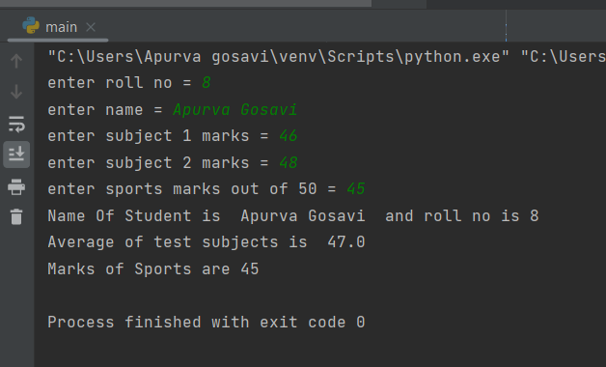

1. **Abstraction:**
2. **Code:**
3. # When we want to provide common interface for different implementations of a component, we use an abstract class.  
   # So, it has declaration but does not have an implementation  
   from abc import ABC, abstractmethod  
   class Shape(ABC):  
    @abstractmethod  
    def area(self):  
    pass  
    def perimeter(self):  
    pass  
     
   class Circle(Shape):  
    def __init__(self,radius): # self: allows to access the variables, attributes, methods of a class  
    self.radius=radius  
    def area(self):  
    return 3.14*self.radius**2  
    def perimeter(self):  
    return 2*3.14*self.radius  
     
   class Square(Shape):  
    def __init__(self,side):  
    self.side=side  
    def area(self):  
    return self.side**2  
    def perimeter(self):  
    return self.side*4  
     
   # create objects of class - objectname= Classname()  
   circle = Circle(3) #(value of radius)  
   square = Square(6) #(value of side)  
     
   # f - formatted literal strings - to evaluate/format the expression within f-string i.e {}  
   print(f"Area of a circle is {circle.area()}")  
   print(f"Perimeter of a circle is {circle.perimeter()}")  
   print(f"Area of a square is {square.area()}")  
   print(f"Perimeter of a square is {square.perimeter()}")

**Output:**

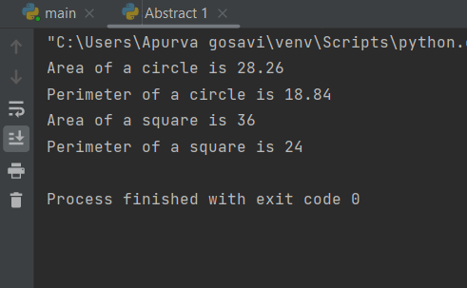

User input modification

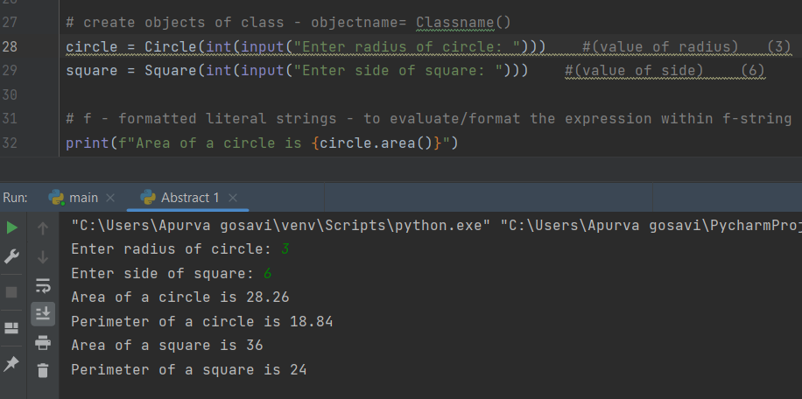

1. **Code (using for loop):**
2. from abc import ABC, abstractmethod  
   class Shape(ABC):  
    @abstractmethod  
    def area(self):  
    pass  
    def perimeter(self):  
    pass  
     
   class Circle(Shape):  
    def __init__(self, radius):  
    self.radius = radius  
    def area(self):  
    return 3.14 * self.radius ** 2  
    def perimeter(self):  
    return 2 * 3.14 * self.radius  
     
   class Square(Shape):  
    def __init__(self, side):  
    self.side = side  
    def area(self):  
    return self.side ** 2  
    def perimeter(self):  
    return self.side * 4  
     
   # Initializing the loop  
   for i in range(0, 100):  
    rad = int(input("Enter radius of circle: "))  
    s = int(input("Enter side of square: "))  
    circle = Circle(rad)  
    square = Square(s)  
    print("When radius is", rad)  
    print("--------------------")  
    print(f"Area of a circle is {circle.area()}")  
    print(f"Perimeter of a circle is {circle.perimeter()}")  
    print("--------------------")  
    print("When side is", s)  
    print("--------------------")  
    print(f"Area of a square is {square.area()}")  
    print(f"Perimeter of a square is {square.perimeter()}")  
    print("--------------------")

**Output:**

